1. **Objective**:

Tableau project for the Somalian Gender Diversification in Education, focusing on analysing statistics related to the gender ratio of students and faculty across different zones, regions, and schools.

1. **Project Details**:

**Project Name**: Somalia Gender in Education Data Visualization

**Project Theme**: Education

**Project Data**: [click](https://data.world/fao-swalim/b80c5b41-0bb3-49b1-a207-8b82cb824fd4)

**Project Published**: [click](https://public.tableau.com/app/profile/nitin.rawat6709/viz/SomaliaGenderinEducationDataVisualization/DashobardGenderInEducation?publish=yes)

1. **Tableau Visualization Explained**:

Below are the 5-visualization explained

1. **Country: Sex Comparison**

**Objective**: Create Visualization that depict gender diversification at country level for a given profession - Student and Faculty

**Visualization**: Percentage Bar Graph

**Key Steps**:

1. Row - Add column Person Type
2. Column - add measure Sum of Person Type i.e. Both Genders in Student and Faculty Profession
3. Then selecting pill in Column, go to Quick Table Calculation --> Percentage of table
4. Now pressing Ctrl add Colum pill to Colour and Text Icon in Marks Pallet
5. In Colour Icon select gray colour for gradient colour scheme principle

**Screenshot of visualization**:

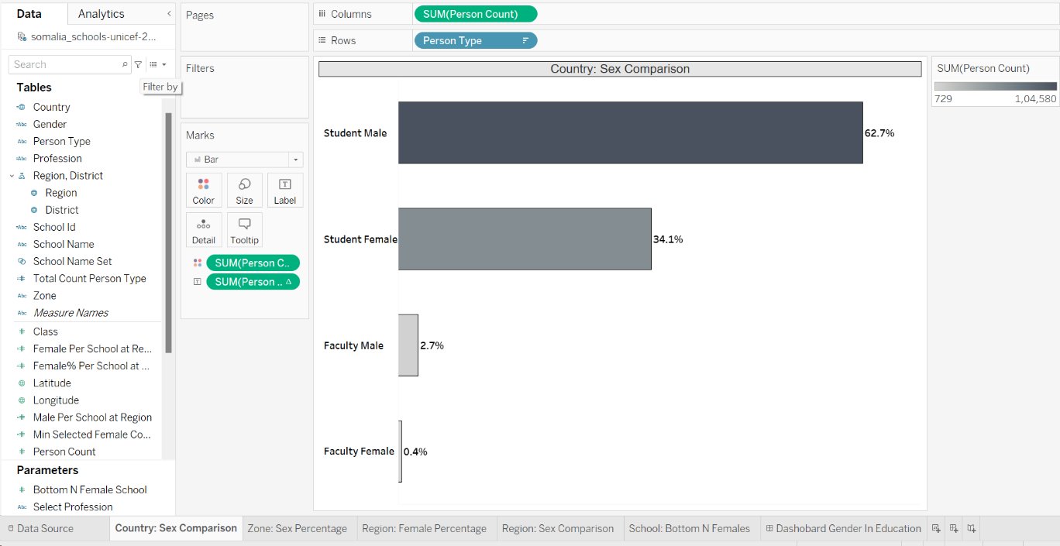

1. **Zone: Professional Sex Ration:**

**Objective**: Creating Visualization communicating comparison percentage of 2 categories residing within different categories.

**Example**: Below is the Profession Category (Student and Faculty) where it has another hierarchy of sex category (Male and Female) at Zone

**Visualization**: Percentage Portion in Bar Graph

**Key Steps**:

1. Row (Category Data Value): The highest level of hierarchy i.e. Professional
2. Column(Measure Data Value): Keep the Sum of Person Count as each records have number of person. Example

School Id (XX) --> Faculty --> Male --> 45 -- It means in school XX, there are 45 male faculty.

Therefore, we are adding values at Column Person Count

1. Filter -
   1. Add Zone as filter
2. Now, we need to detail or break visualization at next level of hierarchy i.e. gender, therefore copy and drag gender to the details in Marks pallet
3. Since we have count, to convert to percentage. Click on the capsule and then select Quick table calculation --> then select **percentage to Total**
4. Now, we have to label this with percentage, therefore format the label and chose 1 decimal of number
5. As, male% from Faculty is the percentage of all records, but we want percentage out of faculty only. Therefore click on capsule of sum person count

At Marks pallet --> click sum of person count capsule --> select compute using --> click gender

Why gender, because this visualization is partition on profession and once gender selected then we will get percentage of gender at professional level.

1. Perform same for capsule at Column to make it uniform

**Screenshot of visualization**:

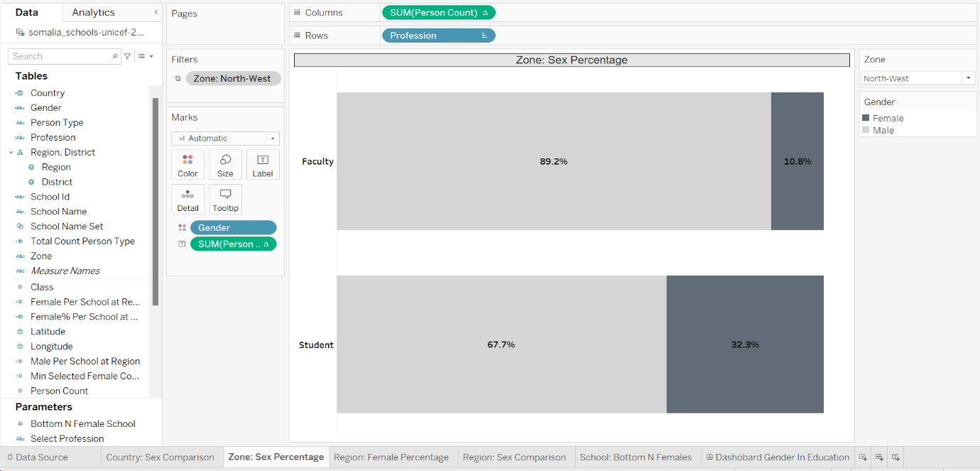

1. **Region: Female Percentage**

**Objective**: Displaying Female percentage for one school at every region in the world map

**Logic Used**: LOD

**Visualization**: World Map with region and label of female percentage for every school

**Key Steps:**

1. As we know every region might have different number of school due to population and geographical area,

Hence, it become necessary to calculate percentage at normalized count of females and male at school level

1. Filter
   1. Add Zone as Filter
2. Creating LOD (Level Of Detail)
   1. Number of Female at Region for every school

Column: Female Per School Per Region: Fixed country, region: if gender = female then sum of person count divide by school id count at region

Column: Male Per School Per Region: Fixed country, region: if gender = male then sum of person count divide by school id count at region

Column: Female % Per School Per Region: (Female Per School Per Region / (Female Per School Per Region + Male Per School Per Region) ) * 100

1. Drag Female % Per School Per Region (LOD) to colour (choose Gray for gradient colour scheme) and label (also, add region)
2. Drag Male Per School Per Region to size (as due to close region and small geographical country something label won't be appropriately visible, therefore keeping

Female % Per School at colour and size for Male Per School Per Region)

**Screenshot of visualization**:

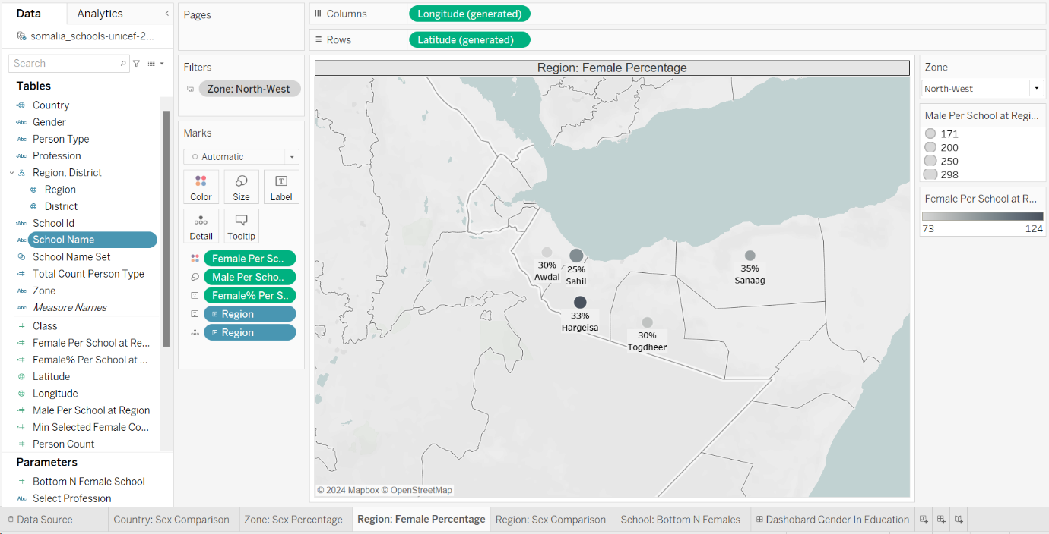

1. **Region: Sex Comparison**

**Objective**: Displaying Gender diversification at Profession for all the given region in a selected zone

**Visualization**: Using Bar for student and line for Faculty gender count with the help of dual axis overlapping logic

**Key Step**s:

1. Column - Adding Region
2. Recreating new columns - holding count of profession:
   1. Person Count Faculty: IF Profession = "Faculty" then Person Count Else 0
   2. Person Count Student: IF Profession = "Student: Then Person count Else 0
3. Column - Add Columns Person Count Faculty and Person Count Student
4. Filter
   1. Add Zone as Filter
5. With above steps two different Bar graph will be generated
6. Right click at the Y axis of bottom bar graph and select dual axis
7. Once merger done, drag Gender to colour and select Gray gradient colour scheme and

make sure to convert Faculty data to line graph with opposite colour scheme for gender

1. No to axis sync as there is big data gap making visualization hard to comprehend

**Screenshot of visualization**:

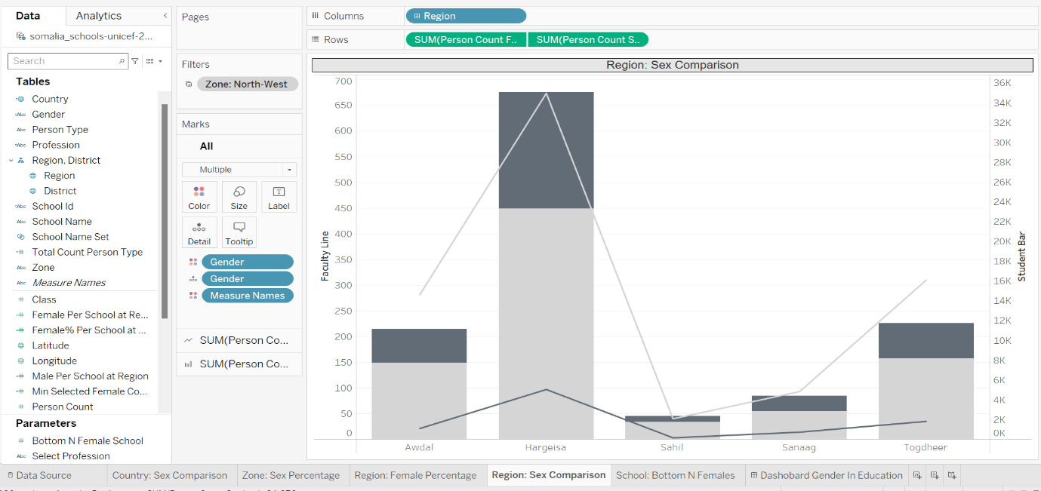

1. **School Bottom N Female**:

**Objective**: providing access to school list to user with least number of selected profession (student or faculty) to be selected by user

with the multiple of 5

**Visualization**: Creating Tab or Contingency Table

**Key Steps:**

1. Row - Profession
2. Column - School Name
3. Parameter Creation -
   1. Bottom N Female with range of 5 to 1000 for step of 5
   2. Select Profession- with string list of Student and Faculty

1. New Calculated Field Creation -
   1. Create a new calculated Field as Min Selected Female

Logic this column will hold the sum of person count based on parameter Select Profession

Say, if Select Profession is Faculty then Min Selected Female will have count of only Female Faculty at school level

Vice versa for student

1. Set - Creating set of Bottom N school based on user selection of profession such as student or faculty
   1. Right click on School Name --> select create set
   2. Once done, then click on menu button Top followed press field by radio button
   3. Select the below configuration:
      1. Select Bottom instead of Top
      2. Instead of 10 select parameter Bottom N Female
      3. Column Min Selected Count
      4. Keep Sum as selected only

1. Filter - Adding Gender and Zone filter as context (to execute prior to any other filter condition)
   1. Gender = "Female"
   2. Zone -> Input from user in the form of single select drop down list
   3. Add School Name Set

**Screenshot of visualization**:

